**---> HDFS Assignment**

1. Create Home Directory on Local File System under /home/cloudera

a. Name it as “localdata”

mkdir /home/clodera/localdata

b. Check and confirm the directory exists

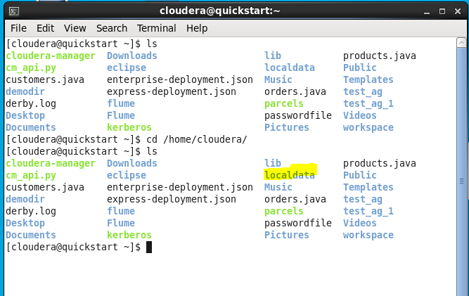

2. Create another Directory on HDFS File System under /user.

a. Name it as “hddata”

hdfs dfs -mkdir /user/hddata

b. Create one more Directory below “hddata”. Name this as “input”

hdfs dfs -mkdir /user/hddata/input

c. Check and confirm the directory exists

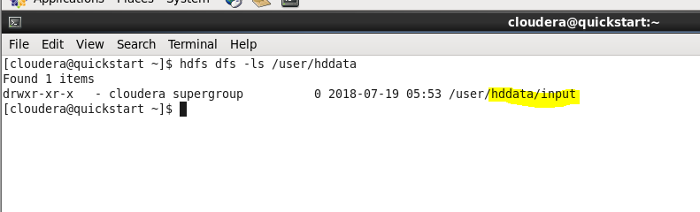

3. Copy the provided file (“newstext.txt”) from your Windows Machine into the “localdata” directory that you created in step 1.

ls /home/cloudera/localdata

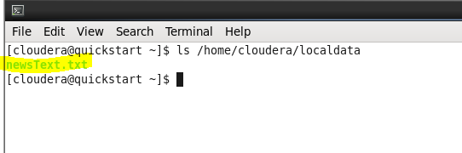

4. Check and confirm the file is copied into the “localdata”.



5. Check the free space on HDFS file system.

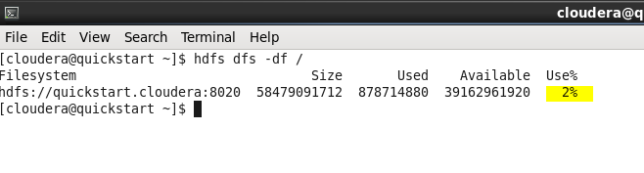

6. Check the displays sizes of files and directories under “/user” on HDFS

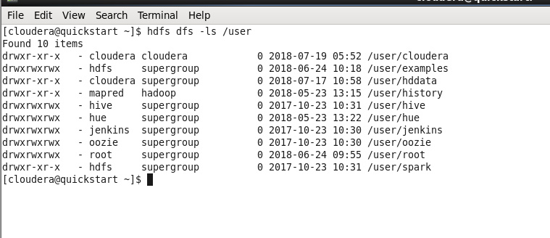

7. Copy “newstext.txt” from local directory to HDFS File System under /user/hddata/input. Confirm the file is copied

hdfs dfs -copyFromLocal /home/cloudera/localdata/newText.txt /user/hddata/input



8. See the content of the file “newstext.txt”. Also, see the last lines of the content in the file.

hdfs dfs -cat /user/hddata/input/newsText.txt

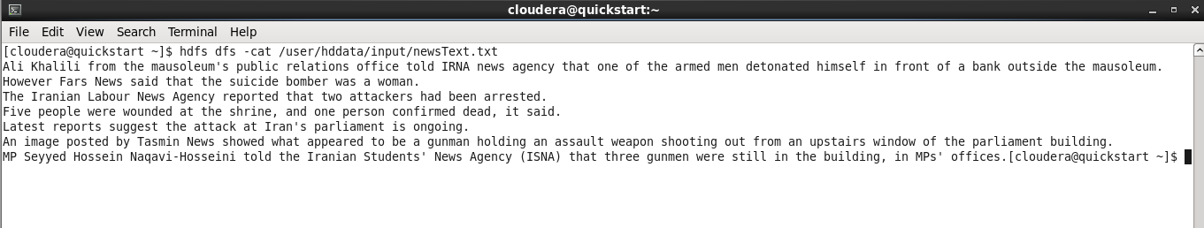

9. Now, Copy “newstext.txt” in your “input’ directory with another name “newnews.txt”

hdfs dfs -cp /user/hddata/input/newsText.txt /user/hddata/input/newnews.txt



10. Rename the “newnews.txt” to “oldnews.txt” and move it to directory “/tmp “

hdfs dfs -mv /user/hddata/input/newnews.txt /user/hddata/input/oldnews.txt

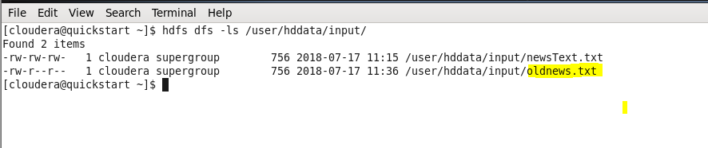

11. Remove the “oldnews.txt” from directory “/tmp”

hdfs dfs -copyToLocal /user/hddata/input/oldnews.txt /tmp

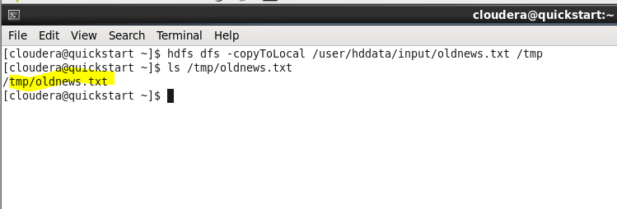

12. Give Read/Write permissions on file “newstext.txt” in your “input’ HDFS directory

hdfs dfs -chmod 666 /user/hddata/input/newsText.txt

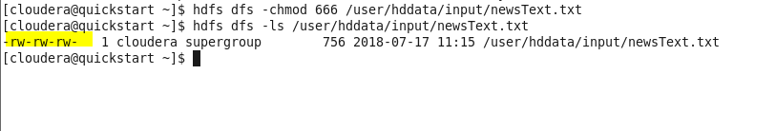

13. Change Ownership from “cloudera” to “hdfs”. Change it back to “cloudera”

sudo -u hdfs hdfs dfs -chown hdfs /user/hddata/input/newsText.txt

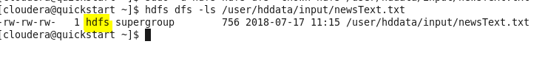

14. Change group ownership from “supergroup” to group “cloudera”

sudo -u hdfs hdfs dfs -chown hdfs:cloudera /user/hddata/input/newsText.txt

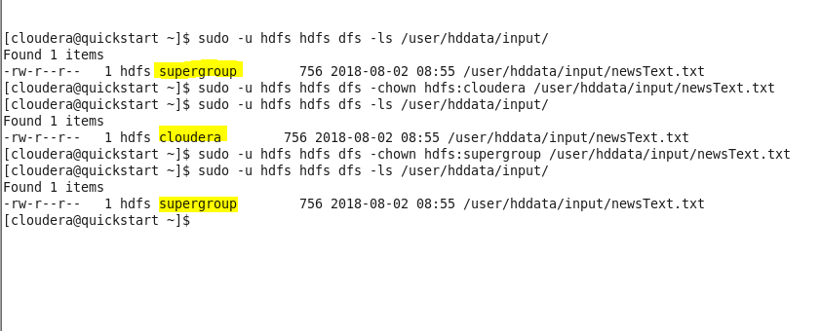

15. Run a DFS File System Check

fsck